   

Group number :1

Project title : Deep Learning Model for Detecting diseases in Tea Leaves

ProjectSubmitted to: IBM

Year : 3rdYear

Department : bio medical engineering Semester :6th

TeamID : NM2023TMID08290

TeamSize :4

TeamLeader :Logeshwari.R

TeamMember :Lisa.E

TeamMember :Malarvizhi.S

TeamMember :Mahalakshmi.E

Guidedby :Shivasakthi

# INTRODUCTION

* 1. **ProjectOverview**

Tea is an important economic crop. It contains a variety of effective ingredients required by the human body, has medical and health care functions, and is quite effective in enhancing human immunity. Planting tea is an important way for tea farmers to make their fortunes. Currently, China’s tea planting area and output are the highest in the world. However,because of the effects of many diseases, such as tea algae leaf spot (TALS), tea bud blight (TBB), tea white scab (TWS), and tea leaf blight (TLB), the annual tea production has been reduced by as much as 20%1. Tea leaf diseases can also reduce the quality of tea and cause serious economic losses to tea farmers. Accurate detection and identiication of tea leaf diseases and timely prevention and control measures are of great significance to reduce the loss of tea production, improve the quality of tea, and increase the income of tea farmers.

Tea leaf diseases can be identified by observing the leaves condition like color and spots on the leaves. Strange spots & colors on the leaves may be an indication of disease. Experts and farmers can identify the type of disease by observing the leaves manually.

At present, the diagnosis of tea leaf diseases relies on the manual method. Most tea trees grow in rugged mountainous areas. Thus, it is time-consuming and costly for experts to go to the tea garden for diagnosis. However, results are largely subjective when famers rely on their own experience to distinguish the types of tea diseases.To overcome the above problem we are building a model which is used for the prevention and early detection of tea leaves disease. Basically tea leaves disease diagnosis depends on the different characteristics like color, spots, texture etc. Here the person can capture the images of the tea leaves and then the image will be sent to the trained model. The model analyzes the image and detects whether the tea leaves are having any disease or not and its type.

# Purpose

The purpose of using deep learning for the detection of diseases in tea leaves is to develop an automated and accurate system for identifying and diagnosing diseases in tea plants. This has several important objectives:

Early Detection: Early detection of diseases in tea leaves is crucial for effective disease management. Deep learning models can be trained to analyze large volumes of tea leaf images and identify subtle visual cues associated with diseases, enabling early detection before the symptoms become visually apparent to human observers.

Accuracy and Reliability: Deep learning models have the potential to achieve high accuracy and reliability in disease detection. By training on a diverse dataset of tea leaf images, the models can learn complex patterns and features associated with specific diseases, improving the accuracy of diagnosis compared to human observation alone.

# IdeationandProposedSolution

* 1. **Problemstatementdefinition**

At present, the diagnosis of tea leaf diseases relies on the manual method. Most tea trees grow in rugged mountainous areas. Thus, it is time-consuming and costly for experts to go to the tea garden for diagnosis. However, results are largely subjective when famers rely on their own experience to distinguish the types of tea diseases.To overcome the above problem we are building a model which is used for the prevention and early detection of tea leaves disease. Basically tea leaves disease diagnosis depends on the different characteristics like color, spots, texture etc. Here the person can capture the images of the tea leaves and then the image will be sent to the trained model. The model analyzes the image and detects whether the tea leaves are having any disease or not and its type.

# Empathymapcanvas

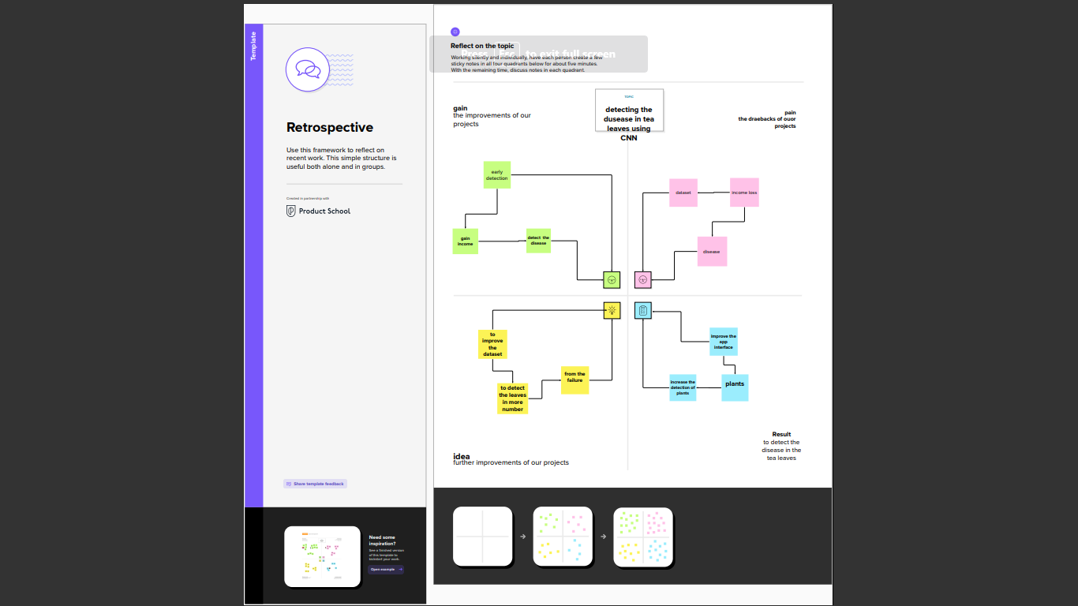

* 1. **IdeationandBrainstorming**

# Step-1:TeamGathering,CollaborationandSelecttheProblemStatement

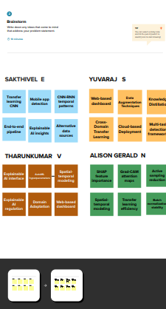

**Step-2:Brainstorm,IdeaListingandGrouping**

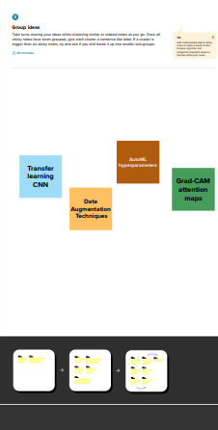

# Step-3:IdeaPrioritization

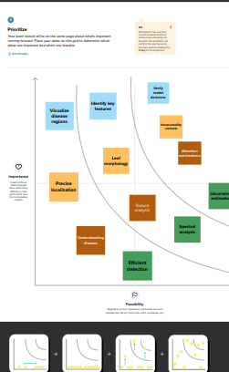

* 1. **Proposedsolution**

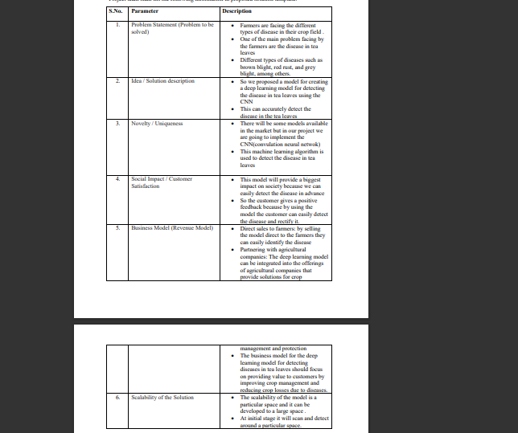

# REQUIREMENTANALYSIS

* 1. **Functionalrequirement**

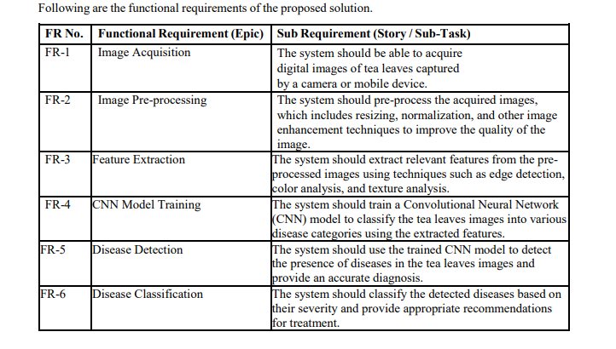

# Non-functionalRequirement

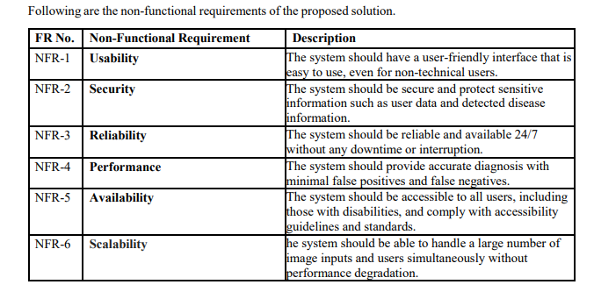

1. **PROJECTDESIGN**

# DATAFLOWDIAGRAMS

A Data Flow Diagram (DFD) is a traditional visual representation of theinformationflowswithinasystem.AneatandclearDFDcandepicttherightamount of the system requirement graphically. It shows how data enters andleavesthesystem,what changestheinformation,and wheredatais

stored

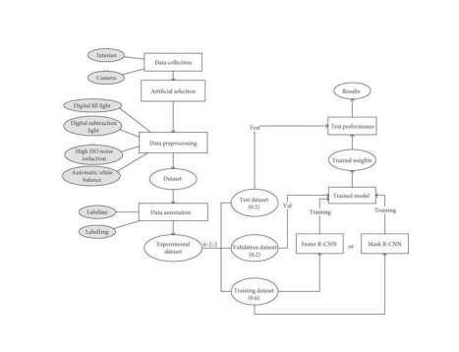

# SolutionandTechnicalArchitecture

**TechnicalArchitecture:**

The Deliverable shall include the architectural diagram as below and theinformation asper the table1 &table2

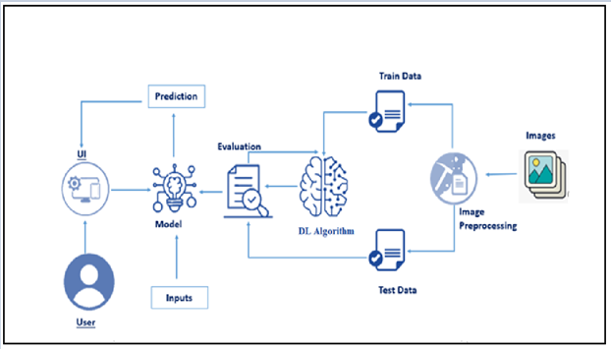

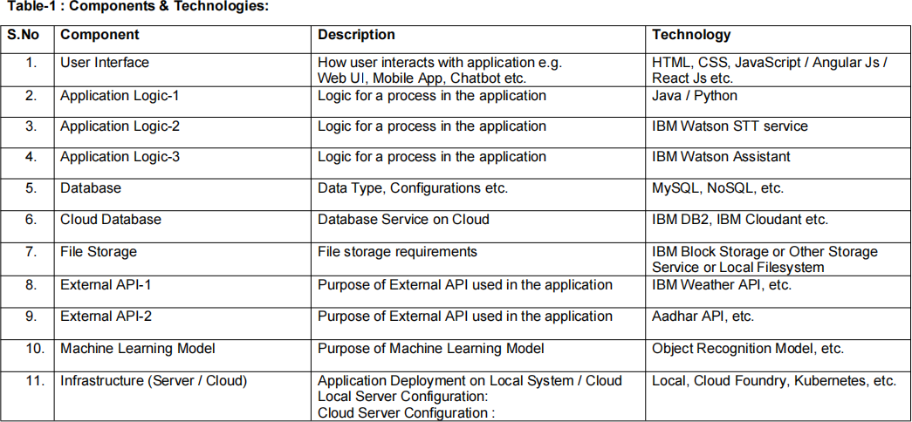

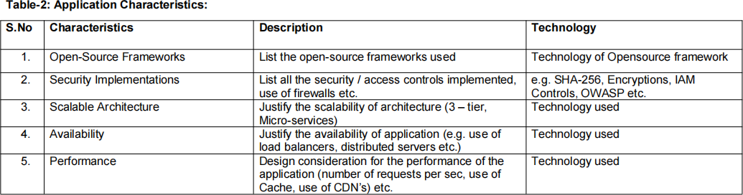

# 4.2UserStories

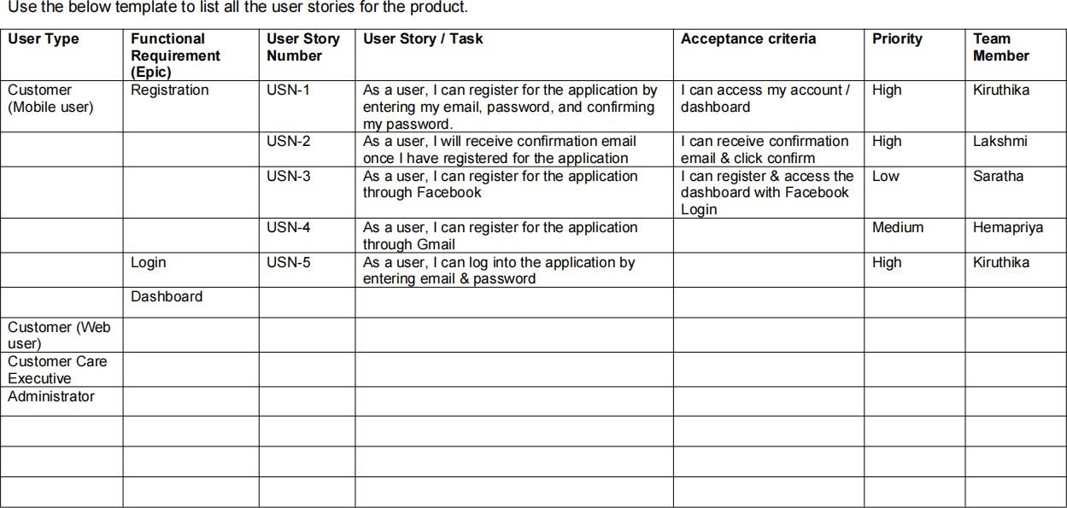

1. **CODINGANDSOLUTIONING**

# Feature1

The features of the existing system are including a user login creator toprovide user interface, student performance analyser, student development card,achieved credit, passing criteria card and wise student performance attributecard. Providing the online interface for students, faculty etc. Increasing theefficiency of school record management. Decrease time required to access anddeliver student records. To make the system more secure. Decrease time spentonnon-value-addedtasks.

The proposed system that we are going to develop will be used as the chiefperformance system for helping the organization in managing the wholedatabaseofthestudentstudyingintheorganization.Therefore,itisexpectedthat the database would perform functionally all the requirements that arespecified.

# Feature2

The proposed system provides the student an easy and accurate data aboutprojectsandacademicpercentages.Studentscanviewalltheinformationinjustone click which saves a lot of time and effort. The proposed system maintains adatabase to store all the information. In this system, there is no chance of losingdata. Adding and searching the information is very easy which does not takemuch time andphysicaleffort.

We developed a website to analyze and generate report of students based onthe curriculum that represents student’s academic performance. We havedeveloped the system such that, it will automatically parse data onto thedatabase from excel file, which will in return reduce time consumption ofanalysisof data.

For these we used HTML, CSS, PHP, my SQL and java script. Afterteacher logins into system, data is been fetched dynamically through thedatabase. For here, parsing is done using PHP Excel. It is an inbuilt library forPHP to fetch data from excel files over or within network. We hope toaccelerate the analysis by developing the analysis system. It provides assistanceto teachers and administrator to track record of each student, subject anddepartmentbyusingvarious techniquessuchsort.

# RESULTS

* 1. **PerformanceMetrices**

**Accuracy:** Accuracy measures how well the disease detection system correctly identifies and classifies tea leaf diseases. It is calculated as the ratio of correctly classified tea leaf samples to the total number of samples. High accuracy indicates reliable disease detection results.

**Precision:** Precision measures the proportion of correctly identified disease cases out of all positive predictions made by the system. It represents the system's ability to avoid false positives, i.e., incorrectly identifying a healthy leaf as diseased. Higher precision indicates fewer false alarms.

**Recall (Sensitivity):** Recall calculates the proportion of correctly identified disease cases out of all actual disease cases. It represents the system's ability to detect actual diseases, avoiding false negatives where a diseased leaf is classified as healthy. Higher recall indicates better disease detection sensitivity.

**F1 Score:** The F1 score is the harmonic mean of precision and recall. It provides a balanced measure of the system's overall performance, taking into account both false positives and false negatives. The F1 score is useful when the dataset is imbalanced, i.e., there is a significant difference in the number of diseased and healthy leaves.

**Specificity:** Specificity measures the proportion of correctly identified healthy leaves out of all actual healthy leaves. It represents the system's ability to avoid false alarms for healthy leaves. Higher specificity indicates a lower rate of misclassifying healthy leaves as diseased.

**Speed**: Speed refers to the time taken by the disease detection system to process and classify tea leaf samples. It is an important consideration for real-time or time-sensitive applications. Faster processing times enable quicker detection and response to disease outbreaks.

**Resource Utilization:** Resource utilization measures the system's efficiency in terms of computational resources, memory usage, and energy consumption. Optimizing resource utilization ensures efficient and scalable disease detection, particularly for large-scale tea plantations.

It's important to note that the choice of performance metrics may vary depending on the specific requirements and constraints of the tea leaf disease detection project. These metrics can help evaluate the performance of the system, identify areas for improvement, and compare different approaches or iterations of the disease detection solution.

# ADVANTAGESANDDISADVANTAGES

**Advantages**

1. Accuracy: Convolutional Neural Networks (CNN) have shown high accuracy in image recognition tasks, making them suitable for detecting and classifying diseases in tea leaves.

2. Automation: The solution automates the disease detection process, reducing the reliance on manual inspection and human expertise. It can process large volumes of tea leaf images quickly and consistently.

3. Early Detection: By detecting diseases in tea leaves at an early stage, prompt action can be taken to prevent the spread of diseases and minimize crop losses, resulting in improved overall plant health and yield.

4. Objectivity: CNN-based disease detection eliminates subjective biases and variations that can occur in manual visual inspection. The solution provides objective and consistent results, ensuring standardized disease identification.

5. Scalability: CNN models can be trained on large datasets, allowing for scalability to handle increasing volumes of tea leaf images as tea plantations grow or new disease patterns emerge.

# Disadvantages

Data Requirements: Training a CNN model requires a substantial amount of labeled data, which can be time-consuming and costly to collect, annotate, and preprocess. The availability of diverse and representative tea leaf images may pose a challenge.

Model Complexity: CNN models can be computationally intensive and require significant computing resources for training and inference. Deploying and maintaining the solution may require powerful hardware or cloud infrastructure.

# CONCLUSION

In conclusion, employing a tea leaf disease detection solution using Convolutional Neural Networks (CNN) offers several advantages in the identification and classification of diseases in tea leaves. The accuracy, automation, early detection, objectivity, and scalability provided by CNN-based solutions contribute to improved plant health, reduced crop losses, and enhanced quality control in the tea industry.

However, challenges and considerations should be taken into account. Gathering and annotating a diverse dataset, addressing model complexity, ensuring interpretability, generalization to new disease patterns, managing false positives and negatives, and the need for technical expertise are crucial factors to consider during solution development and deployment.By carefully addressing these challenges and leveraging the strengths of CNN models, the tea leaf disease detection solution can become a valuable tool for tea plantation owners, farmers, researchers, and quality control managers. It can aid in timely disease management, enhance decision-making, and contribute to the overall sustainability and productivity of tea plantations. Continuous improvement, adaptation, and collaboration among stakeholders will further enhance the effectiveness and reliability of the solution over time.

# 9.FUTUREWORK

# Dataset Enhancement: Collecting a more diverse and comprehensive dataset that includes a wider range of tea leaf diseases, including rare and emerging ones. This will help improve the model's ability to detect and classify various disease types accurately.

# Transfer Learning and Fine-tuning: Investigate the potential of transfer learning techniques to leverage pre-trained CNN models on large-scale image datasets. Fine-tuning these models on tea leaf disease data can help improve detection accuracy and reduce the need for extensive training on limited datasets.

# Real-time Disease Monitoring: Develop real-time disease monitoring systems that can continuously analyze live video streams or images captured from tea plantations. This will enable immediate detection and response to disease outbreaks, allowing for proactive management and timely intervention.APPENDIX

# SOURCECODE

classStudent:

def _init_(self, name, grades):self.name = nameself.grades=grades

defcalculate_average_grade(self):total= sum(self.grades)

returntotal/len(self.grades)

defanalyze_student_performance(students):forstudentinstudents:

average_grade = student.calculate_average_grade()print(f"Student:{student.name}")

print(f"Average Grade: {average_grade}")print(" ")

#Exampleusage

student1=Student("John",[85,90,92,88,95])

student2=Student("Jane",[78,86,92,79,88])

student3=Student("Sam",[90,92,88,85,87])students = [student1, student2, student3]analyze_student_performance(students)**GithubandProjectVideoDemo Link**

VIDEO LINK :<https://youtu.be/9UW5fZhnhdE>

GITHUB LINK :